Diabetes Management

Who should attend?

Caregivers

Case Managers

Direct Support Providers

Guardians

Medical Providers

Date: August 29th, 2017
Diabetes
Time(s) 9:30 am – 12:00 pm
And
Alternatives to Pain
Time(s) 1:30 am – 4:00 pm

Place:

Port Resources
280 B Gannett Drive
South Portland, ME

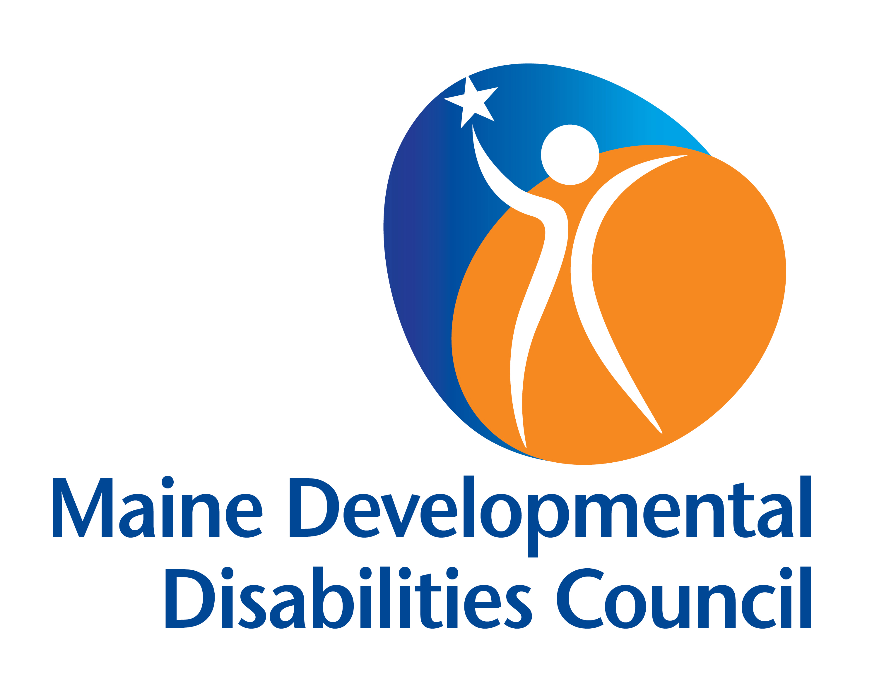

Maine Developmental Disabilities Council
225 Western Avenue, Suite 4
Augusta, Maine 04330
207-287-4213
www.MaineDDC.org
for the Individual with
Developmental Disabilities

In this module, we will discuss the common causes of Diabetes with the emphasis on individuals with developmental disabilities and Autism Spectrum Disorder.

At the end of this training, you will be able to identify:
The four types of Diabetes
The medications that are utilized;
The testing practices and nutritional needs according to their lifestyle and cultural background.

Alternatives to Pain Medication

for the Individual with
Developmental Disabilities

Many individuals who have a developmental disability are sensitive to medications that may be prescribed to them. They are not able to be treated for pain with standard treatment methods and alternatives to standard pain management must be sought. These alternatives are adjuncts and, in some instances, are the method(s) most successful for the individual.

In this module you will receive information on the alternative methods of treating pain in the individual with a
developmental disability.

Focus is placed upon the use of:
Non-prescription medications.
The use of different natural techniques that an individual with DD commonly utilizes that go unnoticed, and
Other alternative therapies that can be utilized.

If you are interested in attending this training, please register by contacting:
The Maine Developmental Disabilities Council by emailing:

angela.b.burgess@maine.gov
or
donald.c.johnson@maine.gov
or you may call
207-287-4213 or 207-287-4215.

